**HR Analytics Report: Employee Retention and Performance Analysis**

**Prepared by:** *Anusha Mourshed*  
**Date:** *Jun 1st, 2025*  
**Project Type:** Exploratory Data Analysis (EDA)  
**Tools Used:** Python (pandas, seaborn, matplotlib), Jupyter Notebook

**1. Introduction**

This report presents a comprehensive analysis of employee data collected from two office branches (A and B) and the HR department. The main objectives are to identify trends associated with employee retention and attrition, uncover workload and satisfaction patterns, and provide actionable insights for Human Resources and management teams.

**2. Data Overview**

Three datasets were combined:

* A_office_data.xml (3,019 records)
* B_office_data.xml (5,981 records)
* hr_data.xml (10,000 records)

All records were cleaned and merged using employee IDs (reindexed as “Axxx” or “Bxxx”) for traceability. The final merged dataset consists of **5,982 employees** and **10 features**, with no missing values.

**3. Employee Activity Insights**

**3.1 Top Contributors by Monthly Hours**

The top 10 employees based on average monthly working hours span multiple departments, including **support, marketing, technical, HR**, and **sales**. All consistently exceed 300+ hours monthly, indicating potential overwork risks in these roles.

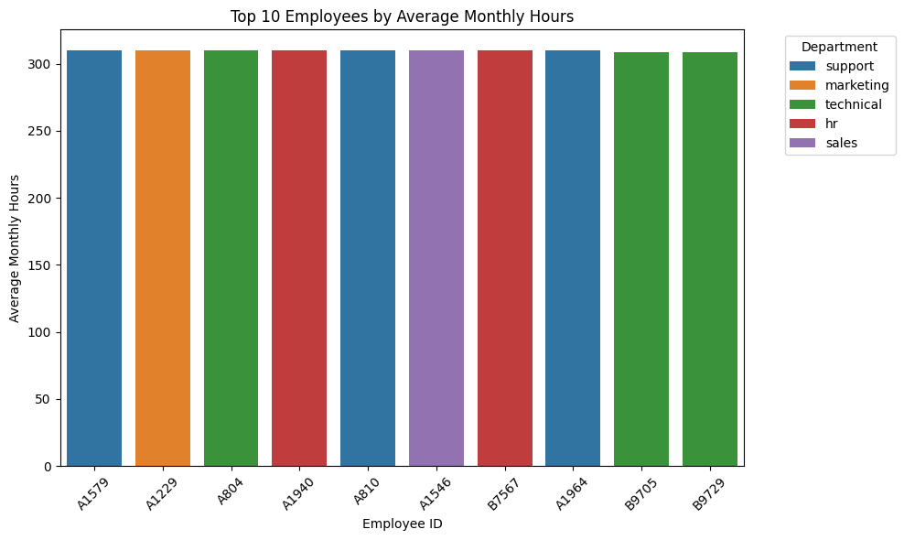

*Figure 1: Top 10 Employees by Average Monthly Hours*

**3.2 Project Load in IT Department**

Employees in the IT department with **low salaries** collectively worked on **847 projects**, significantly higher than their high-salary counterparts. This may suggest wage imbalance relative to workload.

*Figure 2: project distribution among IT employees by salary tier*

**3.3 Case Review of Selected Employees**

The following employees were examined for satisfaction vs evaluation:

* **A4:** Evaluation = 0.87, Satisfaction = 0.72
* **B7064:** Evaluation = 0.56, Satisfaction = 0.36
* **A3033:** Evaluation = 0.94, Satisfaction = 0.93

Low satisfaction and evaluation alignment may indicate performance management issues.

*Figure 3: Performance Snapshot of Selected Employees*

**4. Attrition vs Retention Comparison**

Grouped by left (0 = current, 1 = left):

| **Metric** | **Stayed (0)** | **Left (1)** |
| --- | --- | --- |
| Median Projects | 4.0 | 4.0 |
| Projects > 5 | 207 | 339 |
| Mean Time at Company (yrs) | 3.4 | 3.91 |
| Work Accidents (%) | 18% | 4% |
| Evaluation (mean ± std) | 0.72 ± 0.16 | 0.72 ± 0.20 |

**Insight:** Employees who left had a longer tenure and more intense project workloads, with lower accident rates. This suggests disengagement or stagnation, rather than burnout.

**5. Pivot Table Analysis**

**5.1 Department & Salary Comparison**

A pivot analysis of **median monthly hours** shows:

* In some departments, **high-salary employees worked fewer hours** than medium-salary peers (e.g., IT, technical, support).
* For **employees who left**, low-salary tiers often showed **higher median hours** than high-salary peers, implying potential overwork as a driver of attrition.

*Figure 4: Workload Distribution by Salary Tier*

**5.2 Promotion & Tenure Performance**

Analysis shows that employees **without promotions** often had **higher last evaluation scores**, especially among those with longer tenure (5, 6, 10 years). This may indicate promotion bottlenecks or misaligned recognition.

*Figure 5: Evaluation Score by Promotion Status*

**6. Risk & Correlation Analysis**

**6.1 Attrition Risk Heatmap**

A heatmap revealed that **low-salary employees across nearly all departments** faced higher attrition, with departments like **marketing** and **management** showing the most imbalance.

*Figure 6: attrition rate by department and salary level*

**6.2 Feature Correlation Matrix**

* **Satisfaction Level** has the strongest **negative correlation** with attrition (left, -0.38).
* **Work accident**, **promotion**, and **project count** have minimal impact.
* Interestingly, **last_evaluation** shows little correlation with attrition, suggesting it may not be a good predictor on its own.

*Figure 7: Correlation Matrix of Key HR Metrics*

**7. Conclusions**

* **Satisfaction level is the most significant factor** correlated with employee attrition.
* Departments like **marketing, support, and technical** show signs of imbalance in pay vs workload.
* A **promotion stagnation effect** is visible, especially among longer-tenured employees.
* **IT and low-salary segments** warrant further strategic HR review for workload equity.
* There is room for **data-driven retention interventions**, especially by aligning project loads and performance rewards more fairly.

**8. Recommendations**

* Conduct periodic satisfaction and engagement surveys, especially in departments with high attrition rates.
* Review salary tiers across departments to address inequities tied to workload.
* Introduce transparent promotion and recognition processes for high-performing, long-tenured staff.
* Explore modeling next steps (e.g., logistic regression, decision tree) for predictive attrition classification.